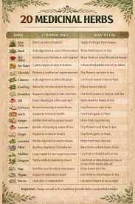
References:
Crystal. (2026, March 9). 20 medicinal herbs you can grow at home. Lettuce Grow Something. https://lettucegrowsomething.com/20-medicinal-herbs-you-can-grow-at-home/

