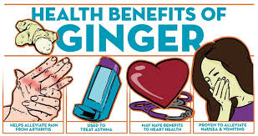

Reference:
Baptist health. (2017). Health benefits of ginger. Baptist Health. https://www.baptisthealth.com/blog/health-and-wellness/health-benefits-of-ginger

