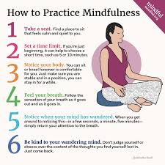

Reference:
Staff, M. (2026a, March 31). How to practice mindfulness. http://mindful.org/how-to-practice-mindfulness/

