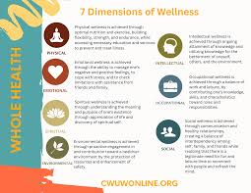

References:
CWU. (2026). 7 dimensions of Wellness — centers of Wellness for Urban Women, Inc.. https://www.cwuwonline.org/7dimensions

