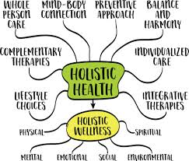

Reference:
Barbara. (2025a). Mind, body, and Soul Approaches. https://bluehorizoncounseling.com/integrative-holistic-approach/

