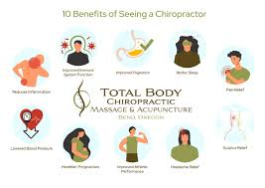

Reference:
Bend Total Body Chiropractic. (2022, March 17). 10 benefits of seeing a chiropractor: Total body in Bend, or. https://bendtotalbodychiropractic.com/chiro-blog/top-10-benefits-of-seeing-a-chiropractor/

