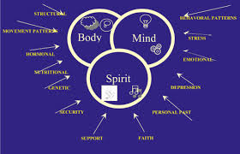

REFERENCES:
MEDICAT. (2025). Bringing Holistic Wellness to college health - medicat. https://medicat.com/bringing-holistic-wellness-to-college-health/

