Purdue Global University
HW320 Contemporary Diet and Nutrition
Nutrition Education Guide

purdue global University

Nutrition Education Guide
By

Khari Pettigrew

Purdue Global University
HW320: Contemporary Diet and Nutrition

10 February, 2026

Table of Contents

Introduction
Unit 1 Dietary Trends and Nutrition
Unit 2 Food Choices
Unit 3 Food ChoiceS: Economics
Unit 4 Food ChoiceS: fOODBORNE iLLNESSES
Unit 5 gENETICALLY eNGINEERED fOOD
Unit 6 tHE oRGANIC fOOD moVEMENT
Unit 7 gLOBAL fOOD mARKETS
Unit 8 cONTEMPORARY weIGHT lOSS pROGRAMS
Unit 9 dIVERSITY OF fOOD chOICES

Unit
1
Dietary Trends and Nutrition
Unit 1 Dietary Trends and Nutrition

Information to Remember:
- USDA Dietary Guidelines– The USDA Dietary Guidelines give evidence-based nutrition recommendations that promote healthier lifestyles. It will also teach you what foods can help prevent chronic disease and help meet nutritional needs. You will learn what makes a balanced meal, including serving sizes of fruits, vegetables, and whole grains. Nutrition is the starting point to having a healthier America.

Resource:
- USDA. (2020). Dietary guidelines for Americans, 2020-2025. https://www.dietaryguidelines.gov/sites/default/files/2020-12/Dietary_Guidelines_for_Americans_2020-2025.pdf

Unit
2
Dietary Trends and Nutrition
Unit 2 Food Choices: Politics, Sociological, Psychological, and Other Influences

Information to Remember:
- Nutrition Misinformation– Nutrition misinformation makes false health claims that can mislead consumers. According to Hermann (2017), “Nutrition fraud is a leading example of health fraud. Nutrition fraud describes abuses that occur as a result of misleading claims for food and nutrition products.” Understanding how to determine whether information is credible can help you make better health decisions.

Resource:
- Hermann, J. R. (2017, July 1). Nutrition misinformation - Oklahoma State University. Nutrition Misinformation | Oklahoma State University. https://extension.okstate.edu/fact-sheets/nutrition-misinformation.html

Unit
3
Dietary Trends and Nutrition
Unit 3 Food Choices: Economics

Information to Remember:
- Food Access– The availability and affordability of nutritious food can be impacted by income and geographic location. Limited access to different foods can lead to higher rates of chronic diseases. According to the USDA (2025), “ Some people and places, especially those with low income, may face greater barriers in accessing healthy and affordable food retailers, which may negatively affect diet and food security.”

Resource:
- USDA. (2025, January 6). Food access. Food Access | Economic Research Service. https://www.ers.usda.gov/topics/food-choices-health/food-access

Unit
4
Dietary Trends and Nutrition
Unit 4 Foodborne Illness and Disease

Information to Remember:
- Foodborne Illness– Contaminated food and beverages can cause foodborne illnesses if it cares bacteria, viruses, and toxins. According to the CDC (2025), “Determining the sources of foodborne illness is an important part of identifying opportunities to improve food safety.” To prevent foodborne illnesses, you need to make sure to wash your hands often and don’t cross-contaminate foods.

Resource:
- CDC. (n.d.). Foodborne illness source estimates. Centers for Disease Control and Prevention. https://www.cdc.gov/food-safety/php/data-research/foodborne-illness-sources/?CDC_AAref_Val=https%3A%2F%2Fwww.cdc.gov%2Ffoodborneburden%2Fattribution%2Fattribution-1998-2008.html

Unit
5
Dietary Trends and Nutrition
Unit 5 Genetically Engineered Food

Information to Remember:
- GMOs– According to the FDA (2024), “The U.S. Food and Drug Administration (FDA), U.S. Environmental Protection Agency (EPA), and U.S. Department of Agriculture (USDA) ensure that GMOs are safe for human, plant, and animal health.” GMOs Can provide benefits such as longer shelf lives and resistance to pests. Understanding the regulations allowed me to understand that not all GMOs are bad.

Resource:
- FDA. (2024, May 5). How gmos are regulated. U.S. Food and Drug Administration. https://www.fda.gov/food/agricultural-biotechnology/how-gmos-are-regulated-united-states

Unit
6
Dietary Trends and Nutrition
Unit 6 The Organic Food Movement

Information to Remember:
- Organic vs Conventional– Many people believe that just because food has the organic title, it is healthier, but it just identifies how it was grown. According to Mayo Clinic (2025), “A healthy diet can include food grown organically or using typical farming methods, called conventional farming.” Organic food often costs more than conventional food, which makes it harder to maintain a fully organic diet.

Resource:
- Mayo Clinic. (2025, February 28). Organic Foods: ARE THEY SAFER? more nutritious? https://www.mayoclinic.org/healthy-lifestyle/nutrition-and-healthy-eating/in-depth/organic-food/art-20043880

Unit
7
Dietary Trends and Nutrition
Unit 7 Globalization of World Food Markets

Information to Remember:
- Globalization of fast food– Globalization has benefits for the fast-food companies, but it can hurt the local economy. According to Ewing-Chow (2019), “Food globalization has concurrently raised a number of concerns in the international development community; among these, the marginalization of locally grown foods and the proliferation of unhealthy— high-sodium, high-fat, highly processed diets.” Globalization has led to higher cases of chronic disease in several countries, while also causing fear of cultural appropriation.

Resource:
- Ewing-Chow, D. (2019, April 19). The globalization of fast food, public health and why we should have an eye on Jamaica. https://www.forbes.com/sites/daphneewingchow/2019/04/18/the-globalisation-of-fast-food-public-health-and-why-we-should-have-our-eye-on-jamaica/

Unit
8
Dietary Trends and Nutrition
Unit 8 Contemporary Weight-Loss Programs

Information to Remember:
- Prescription Medications to Treat Overweight & Obesity– According to the NIH (2025), “Your health care professional may prescribe a medication to treat your overweight or obesity if you are an adult with a BMI of 30 or greater, a BMI of 27 or greater, and you have weight-related health problems such as high blood pressure NIH external link or type 2 diabetes” Many people use these prescription medications as way to obtain a look instead of fixing their diets and physical activity. Without changing your lifestyle, you are at a higher risk of regaining weight.

Resource:
- NIH. (2025). Prescription medications to treat overweight & obesity - NIDDK. National Institute of Diabetes and Digestive and Kidney Diseases. https://www.niddk.nih.gov/health-information/weight-management/prescription-medications-treat-overweight-obesity

Unit
9
Dietary Trends and Nutrition
Unit 9 Diversity of Food Choices

Information to Remember:
- Certifications– According to the NCR (2021), “In most of these fitness and sport nutrition certifications, you learn the fundamentals of nutrition science. Things like: food intake, digestion, absorption, macronutrients, micronutrients, body weight, body composition, and performance.” These certifications can enhance a professional's credibility and competency. They will also be able to learn new ways to improve their ability to guide clients in a safe and effective way.

Resource:
- NCR. (2021, March 10). Best Fitness & Sports Nutrition Certification Programs. https://nutritioncertificationreviews.com/best-fitness-sports-nutrition-certification-programs/

Part 2: Cultural Food Choice Explanation and Screenshot
I am African American, and my wife is Filipina, and ever since we have been married, I have had an interest in her cultural food. According to Gilbuena (2021), “So what is Filipino food? Put simply: It's what you'd get if Asian, Spanish, and American food had a baby.” Many meals often balance sweet, salty, sour, and savory tastes, eaten with rice. The most common ingredients are rice, soy sauce, vinegar, seafood, and pork. Food plays an important role in all celebrations, holidays, and family gatherings. For many of these celebrations, there are the same dishes: Chicken Adobo, Pancit, lumpia, sinigang, etc. For this assignment, I prepared Sinigang because it is one of my favorite Filipino dishes. This is a comforting soup-type meal with many ingredients and a delicious sour taste. The biggest challenge for me was achieving the right level of sourness without overpowering the dish. I love my sinigang super sour, but my wife and kids don’t, so I had to continue to taste the soup to ensure I made it perfectly. Ingredients include Pork rib, water, tamarind, onion, garlic, daikon, bok choy, and green beans. This meal turned out very delicious, and I will definitely cook and eat it again.
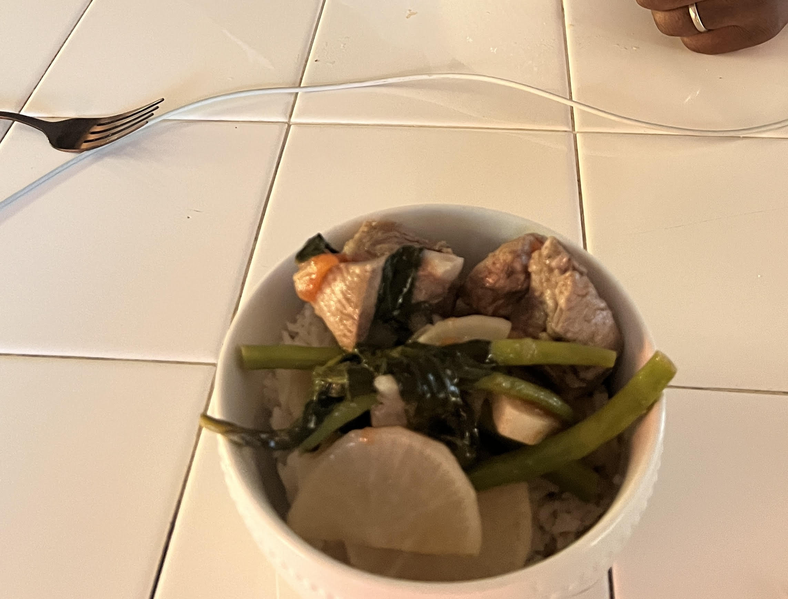

References:

CDC. (n.d.). Foodborne illness source estimates. Centers for Disease Control and Prevention. https://www.cdc.gov/food-safety/php/data-research/foodborne-illness-sources/?CDC_AAref_Val=https%3A%2F%2Fwww.cdc.gov%2Ffoodborneburden%2Fattribution%2Fattribution-1998-2008.html
Ewing-Chow, D. (2019, April 19). The globalization of fast food, public health and why we should have an eye on Jamaica. https://www.forbes.com/sites/daphneewingchow/2019/04/18/the-globalisation-of-fast-food-public-health-and-why-we-should-have-our-eye-on-jamaica/
FDA. (2024, May 5). How gmos are regulated. U.S. Food and Drug Administration. https://www.fda.gov/food/agricultural-biotechnology/how-gmos-are-regulated-united-states
Gilbuena, Y. (2021, July 14). Intro to Filipino food and culture with Yana Gilbuena. Allrecipes. https://www.allrecipes.com/article/yana-gilbuena-filipino-food-culture/
Hermann, J. R. (2017, July 1). Nutrition misinformation - Oklahoma State University. Nutrition Misinformation | Oklahoma State University. https://extension.okstate.edu/fact-sheets/nutrition-misinformation.html
Mayo Clinic. (2025, February 28). Organic Foods: ARE THEY SAFER? more nutritious? https://www.mayoclinic.org/healthy-lifestyle/nutrition-and-healthy-eating/in-depth/organic-food/art-20043880
NCR. (2021, March 10). Best Fitness & Sports Nutrition Certification Programs. https://nutritioncertificationreviews.com/best-fitness-sports-nutrition-certification-programs/
NIH. (2025). Prescription medications to treat overweight & obesity - NIDDK. National Institute of Diabetes and Digestive and Kidney Diseases. https://www.niddk.nih.gov/health-information/weight-management/prescription-medications-treat-overweight-obesity
USDA. (2020). Dietary guidelines for Americans, 2020-2025. https://www.dietaryguidelines.gov/sites/default/files/2020-12/Dietary_Guidelines_for_Americans_2020-2025.pdf
USDA. (2025, January 6). Food access. Food Access | Economic Research Service. https://www.ers.usda.gov/topics/food-choices-health/food-access

