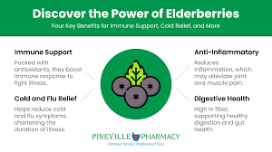

Reference:
Pineville pharmacy. (2025, January 14). Elderberry - Pineville pharmacy. Pineville Pharmacy | Pharmacy in Pineville, NC. https://pinevillepharmacy.com/pharmacy-elderberry/

